SMTP (PORT 25) Penetration Testing

- Lab Setup
- Target machine ubuntu : 192.168.1.12 (IP Address)
- Attacking machine kali : 192.168.1.42 (IP Address)

- Host Name Configuration
sudo nano /etc/hosts
Here change with the domain name on not .com or .in anything
mail.kiran.com kiran
cat /etc/hosts
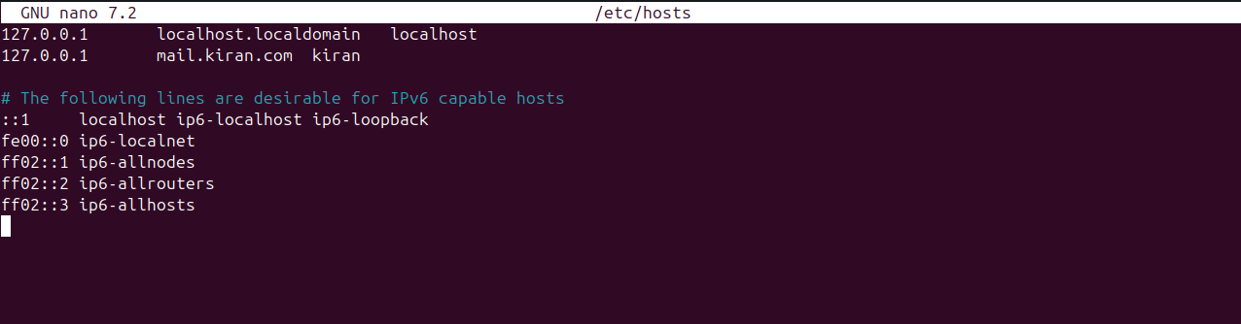

To check :
- hostname
- hostname -f
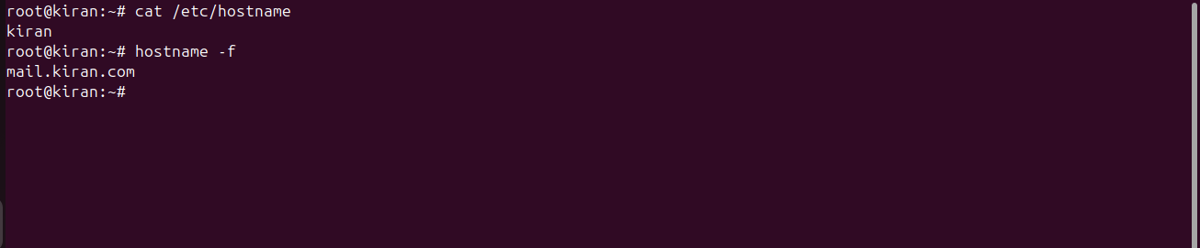

- Postfix Installation
cmd:- sudo apt-get install postfix
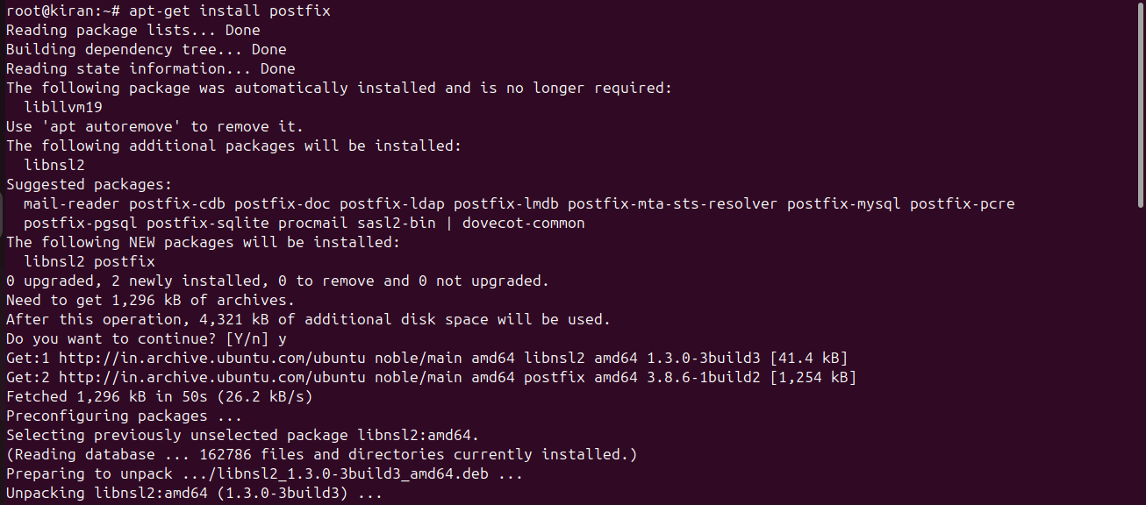

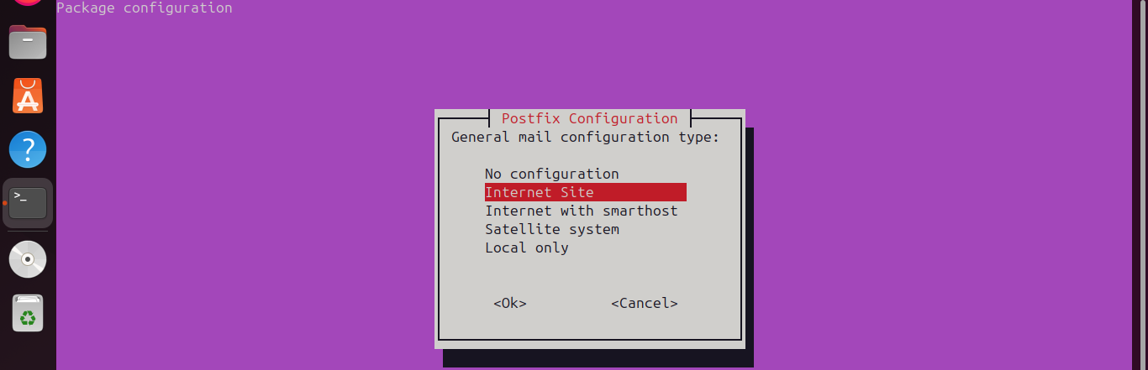

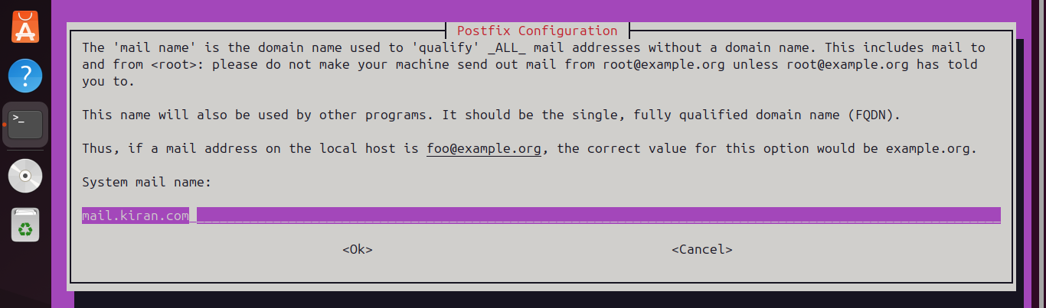

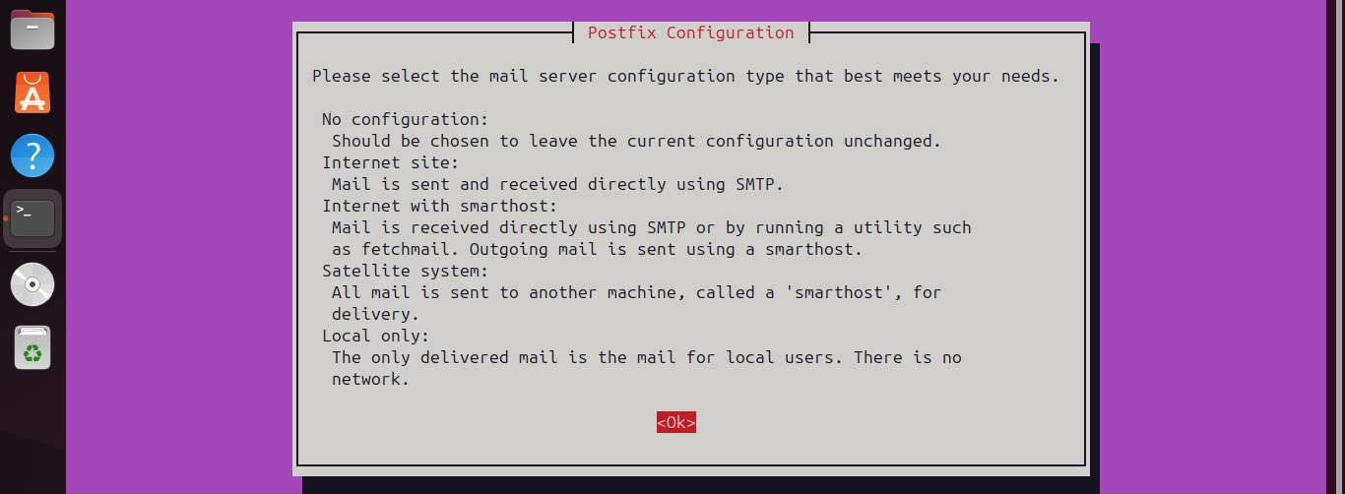
- sudo nano /etc/postfix/main.cf
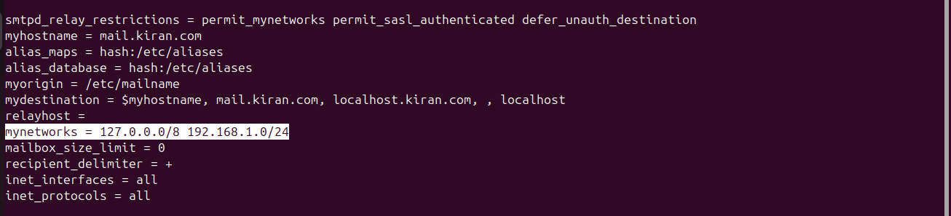
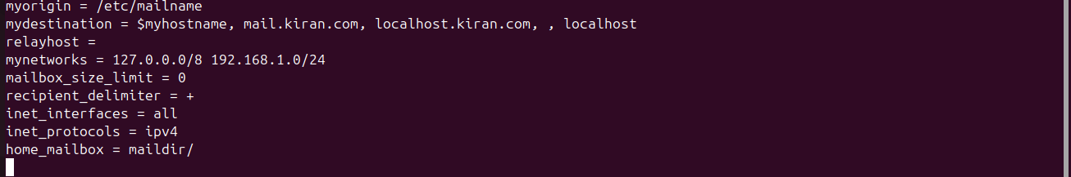
- service postfix restart
- netstat -tnl or -ntnl
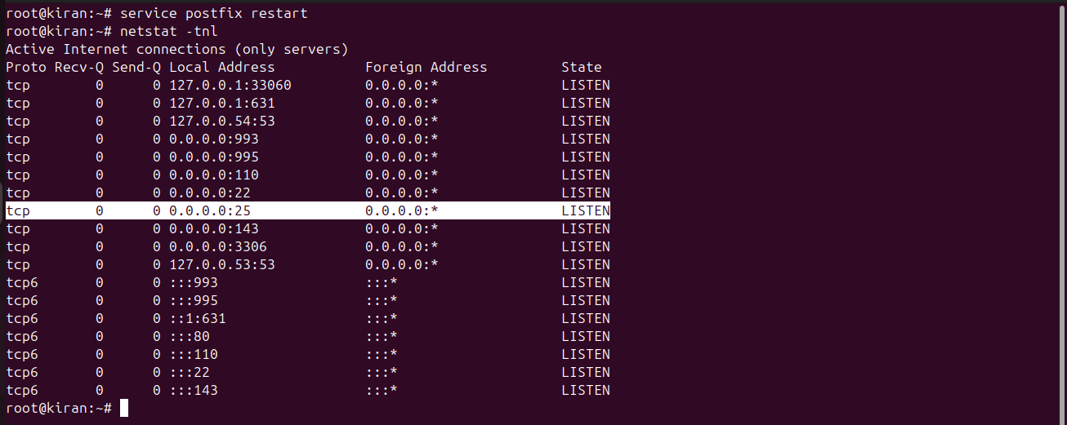
- Installation of Dovecot
- Its agent POP3 and IMAP
sudo apt-get install dovecot-imapd dovecot-pop3d
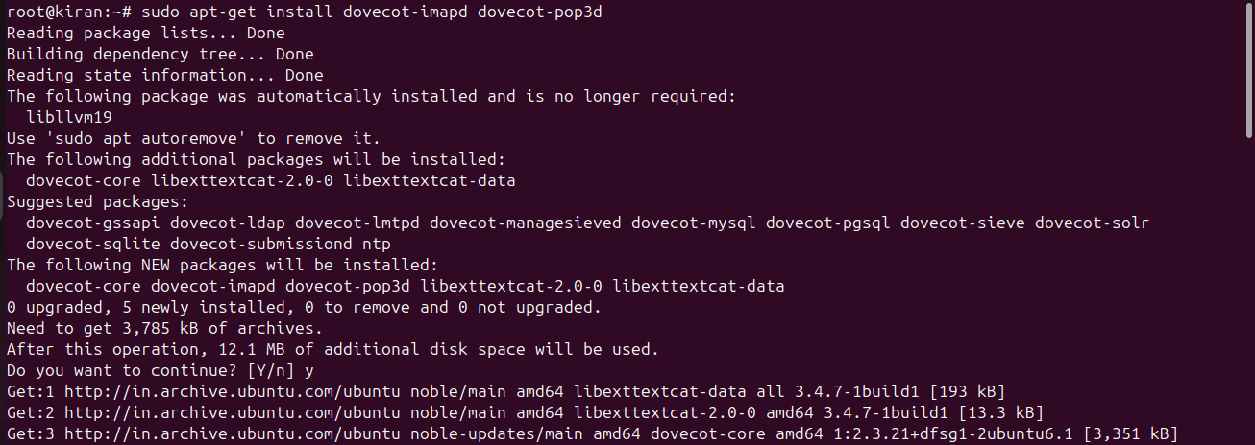
- cd /etc/dovecot/conf.d
- sudo nano 10-auth.conf
- Change to diasble_plaintext_auth = yes
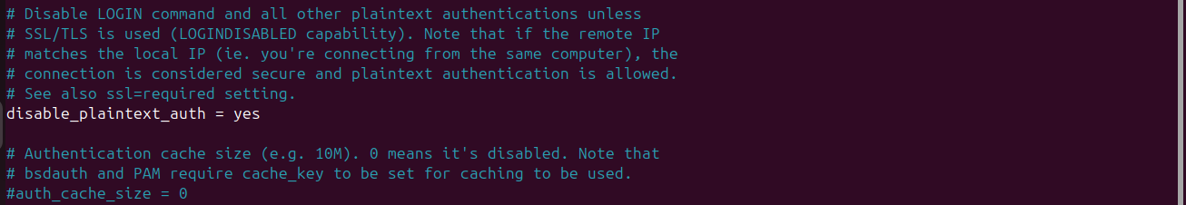
- Chage auth_mechenisms = plain login
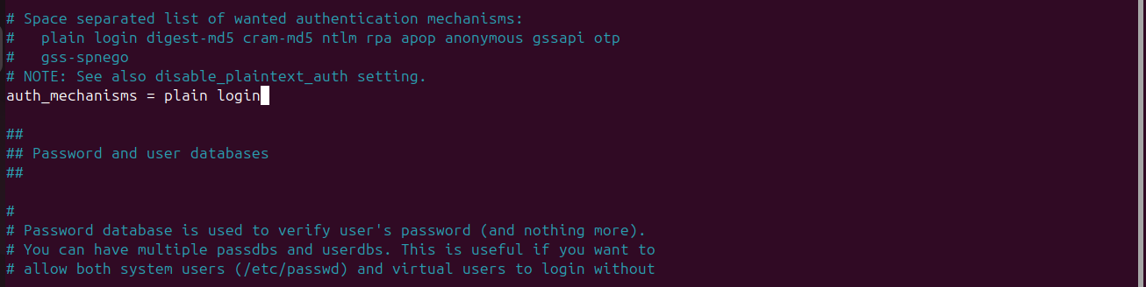
- sudo nano 10-mail.conf
- Change mail_location = maildir:/home/%u/Maildir
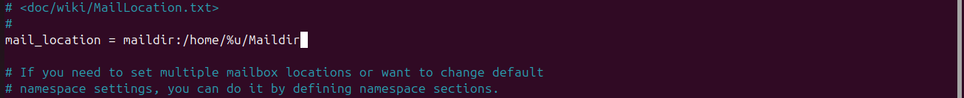
- sudo nano 10-master.conf
- Remove # -> port = 143
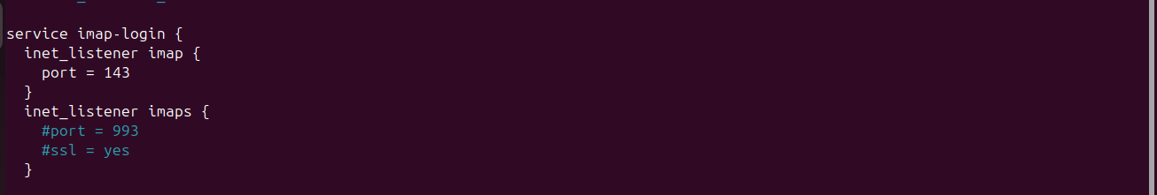
- Remove # -> port = 110
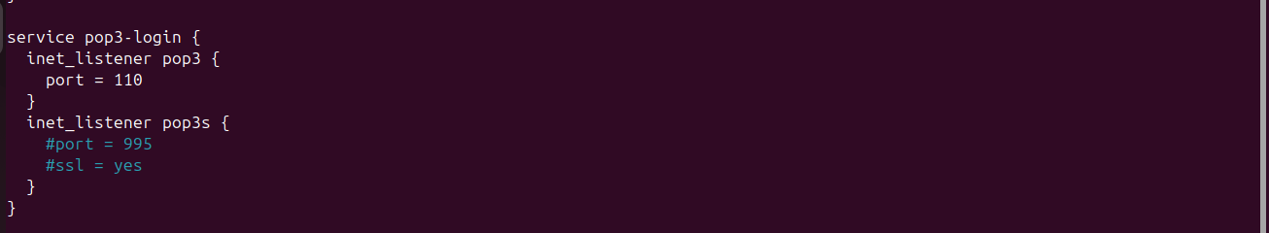
- Add user & group = postfix
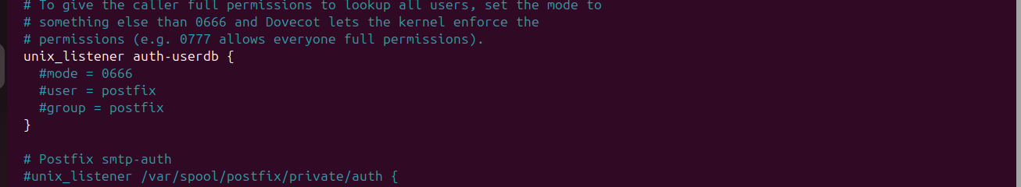

- Service dovecot restart
- Netstart -ntnl or -tnl
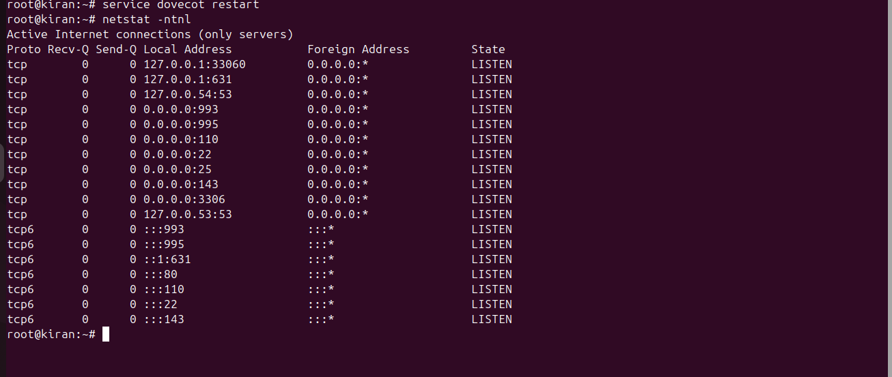
- Installing Rain Loop
sudo apt install apache2 php php-curl php-json php-iconv php-xml php-dom php-mysql php-pdo libapache2-mod-php
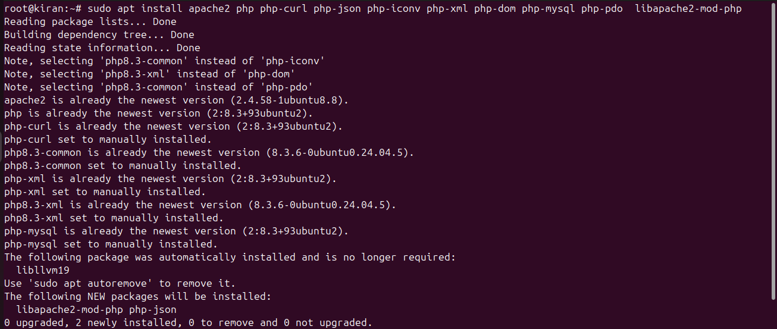
sudo apt install curl
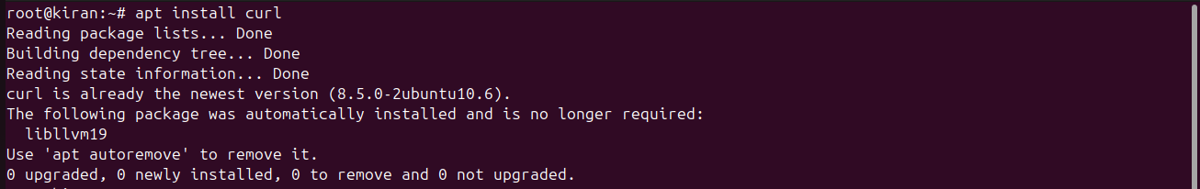
- cd /var/www/html
- rm *

Curl -s https://repository.rainloop.net/installer.php |sudo php
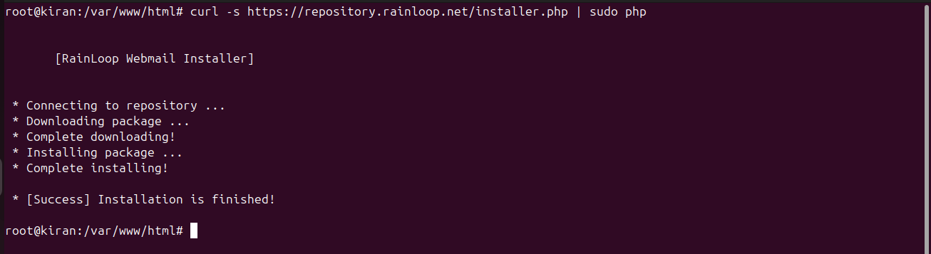
http://localhost/?admin
